Chapter Four

Results and Discussion

This chapter presents the complete experimental results and critical analysis of the Smart Diabetes Monitoring and Prediction System. All results are derived from the BRFSS 2015 dataset and reported on the held-out test set of 45,895 records unless explicitly stated otherwise. The chapter is organized to follow the logical sequence of the pipeline: training results across the three progressive feature phases, hyperparameter tuning, threshold optimization, final deployment performance, comparison with prior literature, and a clinical interpretation of the key findings.

4.1 Experimental Setup
The experimental evaluation is conducted on the BRFSS 2015 dataset comprising 253,680 records with a binary diabetes target variable. Following stratified 80/20 splitting, 183,579 records are allocated for training and 45,895 records are reserved as a completely held-out test set. Stratification preserves the original 86 to 14 percent class distribution in both subsets, maintaining the 6.18 to 1 majority-to-minority imbalance ratio throughout all phases [12], [41]. The test set contains 7,019 diabetic cases and 38,876 non-diabetic cases.
Seven classification algorithms are evaluated across three progressive feature phases as described in Chapter 3: Phase 1 on the original 21 BRFSS features, Phase 2 on the expanded 45-feature engineered space, and Phase 3 on a reduced top-15 feature subset. All models are configured with explicit imbalance handling mechanisms and evaluated using the clinically weighted composite scoring function defined in Chapter 3, Section 3.6.4. A fixed random seed is applied globally to ensure full reproducibility of all reported results [25], [35]. Table 4.1 summarizes the key experimental configuration parameters.

Table 4.1
Experimental setup summary.
Component | Specification
Dataset | BRFSS 2015
Total Records | 253,680
Train / Test Split | 183,579 / 45,895 (stratified 80/20)
Test Set Diabetic Cases | 7,019 (15.3% of test set)
Class Imbalance Ratio | 6.18 : 1
Feature Phases | Phase 1: 21 features, Phase 2: 45 features, Phase 3: 15 features
Algorithms Evaluated | 7 per phase (21 total model-phase combinations)
Validation Strategy | Stratified 5-Fold Cross-Validation
Model Selection Criterion | Clinically weighted composite score (Recall 40%)
Clinical Recall Constraint | Recall ≥ 0.90 (non-negotiable deployment criterion)

4.2 Model Training Results
Model training is conducted across three progressive experimental phases. Each phase builds upon the preceding one to assess the incremental contribution of feature engineering and feature selection to predictive performance. All seven algorithms are retrained from scratch in each phase under identical imbalance handling configurations and evaluated on the same held-out test set.

4.2.1 Baseline Phase Results
In Phase 1, all seven algorithms are trained on the original 21 BRFSS features without any feature engineering, establishing a performance benchmark for comparison with subsequent phases. Table 4.2 presents the full evaluation metrics for all seven algorithms sorted by composite score.

Table 4.2
Performance of all seven algorithms on the original 21 BRFSS features (Phase 1), sorted by composite score.

Model | Acc | Pr | Recall | F1 | ROC-AUC | PR-AUC | BalAcc | MCC | Composite
LightGBM | 0.4416 | 0.2109 | 0.9674 | 0.3464 | 0.8156 | 0.4431 | 0.6570 | 0.2470 | 0.6942
CatBoost | 0.7150 | 0.3206 | 0.7716 | 0.4530 | 0.8131 | 0.4338 | 0.7382 | 0.3556 | 0.6570
XGBoost | 0.7067 | 0.3131 | 0.7686 | 0.4449 | 0.8051 | 0.4204 | 0.7321 | 0.3450 | 0.6508
Logistic Regression | 0.7143 | 0.3182 | 0.7595 | 0.4485 | 0.8106 | 0.4121 | 0.7329 | 0.3482 | 0.6495
AdaBoost | 0.8529 | 0.5545 | 0.1943 | 0.2878 | 0.8142 | 0.4336 | 0.5831 | 0.2655 | 0.3682
Gradient Boosting | 0.8557 | 0.5944 | 0.1777 | 0.2736 | 0.8193 | 0.4473 | 0.5779 | 0.2684 | 0.3591
Random Forest | 0.8443 | 0.4713 | 0.1507 | 0.2284 | 0.7814 | 0.3580 | 0.5601 | 0.2006 | 0.3217
Extra Trees | 0.8330 | 0.3909 | 0.1647 | 0.2318 | 0.7512 | 0.3143 | 0.5592 | 0.1735 | 0.3194

Two distinct behavioral clusters emerge from Phase 1 results. The first cluster consists of LightGBM, CatBoost, XGBoost, and Logistic Regression, all of which achieve Recall values above 0.75 through effective imbalance handling. The second cluster consists of AdaBoost, Gradient Boosting, Random Forest, and Extra Trees, all of which achieve Recall values below 0.20 despite achieving high overall accuracy above 0.83, demonstrating the well-documented phenomenon of majority-class dominance when classifiers do not adequately account for class imbalance [9], [10]. A trivial majority-class classifier would achieve accuracy of 0.86 on this dataset while achieving MCC of approximately 0, confirming that overall accuracy is a misleading and clinically inappropriate primary metric [43], [45].
LightGBM achieves the highest composite score of 0.6942 and the highest Recall of 0.9674 in Phase 1, positioning it as the strongest baseline candidate. Its ROC-AUC of 0.8156 and PR-AUC of 0.4431 confirm strong discriminative ability substantially above the no-skill PR baseline of approximately 0.15 [31], [32].

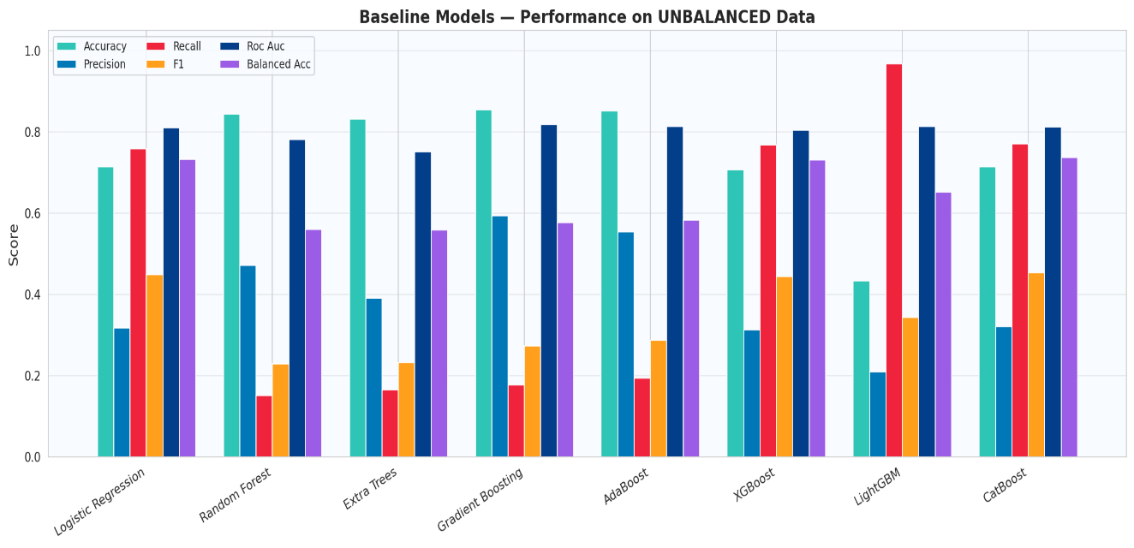

Figure 4.1
Performance comparison of all seven algorithms across key metrics in Phase 1 (Baseline).

4.2.2 Engineered Features Phase Results
In Phase 2, domain-informed feature engineering expands the feature space from 21 to 45 features through the 24 clinically derived attributes described in detail in Chapter 3, Section 3.5. Table 4.3 presents the full evaluation metrics for Phase 2.

Table 4.3
Performance of all seven algorithms on the 45-feature engineered space (Phase 2), sorted by composite score.

Model | Accuracy | Precision | Recall | F1 | ROC-AUC | PR-AUC | BalAcc | MCC | Composite
LightGBM | 0.4479 | 0.2127 | 0.9658 | 0.3486 | 0.815 | 0.442 | 0.660 | 0.250 | 0.6944
Logistic Regression | 0.7153 | 0.3212 | 0.7742 | 0.4541 | 0.816 | 0.439 | 0.739 | 0.357 | 0.6591
CatBoost | 0.7173 | 0.3212 | 0.7622 | 0.452 | 0.809 | 0.428 | 0.736 | 0.353 | 0.6518
XGBoost | 0.7099 | 0.3153 | 0.7655 | 0.4466 | 0.805 | 0.418 | 0.733 | 0.347 | 0.6501
AdaBoost | 0.8539 | 0.5741 | 0.1734 | 0.2663 | 0.810 | 0.425 | 0.575 | 0.258 | 0.3524
Gradient Boosting | 0.8555 | 0.6 | 0.1646 | 0.2583 | 0.819 | 0.445 | 0.573 | 0.260 | 0.3488
Extra Trees | 0.8337 | 0.4047 | 0.1861 | 0.2549 | 0.752 | 0.318 | 0.568 | 0.192 | 0.3361
Random Forest | 0.8423 | 0.4533 | 0.1499 | 0.2253 | 0.777 | 0.353 | 0.559 | 0.193 | 0.3188

Feature engineering produces measurable improvements in composite score for the leading models. LightGBM improves from 0.6942 to 0.6944 and Logistic Regression improves from 0.6495 to 0.6591, confirming that the engineered features provide incremental predictive signal beyond what raw survey items capture [37], [17]. The improvement in Logistic Regression is particularly notable as it is the most linearly constrained model in the set, suggesting that composite and interaction features make non-linear relationships more accessible to linear classifiers by encoding them as explicit input dimensions [21].
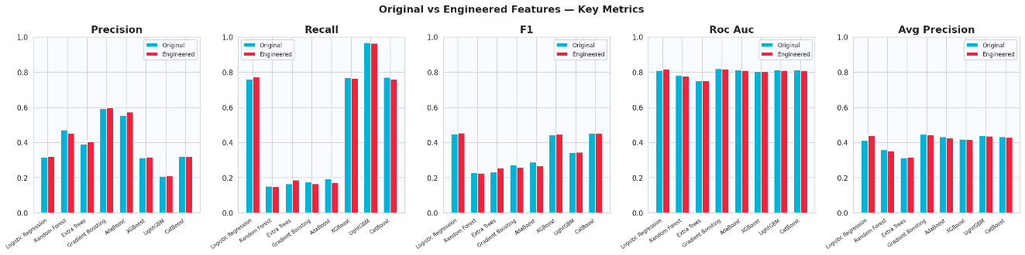

Figure 4.2
Comparison of key metrics between Phase 1 (original features) and Phase 2 (engineered features) per algorithm.

4.2.3 Selected Features Phase Results
In Phase 3, the top-15 feature subset identified through the combined Random Forest MDI and Mutual Information ranking described in Chapter 3, Section 3.5.6 is used for training. The 15 selected features are: GenHlth_x_BMI, Age_x_BMI, CompositeRiskScore, CardioRisk, GenHlth_Sq, HighBP, BMI_Sq, BMI, GenHlth, Age_Sq, Income, Age, SocioEconomic, Education, and HighChol. Table 4.4 presents the full evaluation metrics for Phase 3.

Table 4.4
Performance of all seven algorithms on the top-15 selected features (Phase 3), sorted by composite score.

Model | Accuracy | Precision | Recall | F1 | ROC-AUC | PR-AUC | BalAcc | MCC | Composite
LightGBM | 0.4287 | 0.207 | 0.9659 | 0.341 | 0.811 | 0.436 | 0.649 | 0.237 | 0.6898
Logistic Regression | 0.7118 | 0.3168 | 0.7646 | 0.448 | 0.811 | 0.430 | 0.734 | 0.348 | 0.6515
CatBoost | 0.7075 | 0.3132 | 0.7649 | 0.445 | 0.806 | 0.421 | 0.731 | 0.344 | 0.6492
XGBoost | 0.7021 | 0.3087 | 0.7645 | 0.440 | 0.801 | 0.414 | 0.728 | 0.338 | 0.6462
Extra Trees | 0.7715 | 0.2877 | 0.3347 | 0.309 | 0.675 | 0.245 | 0.593 | 0.174 | 0.3932
Random Forest | 0.7977 | 0.3202 | 0.2875 | 0.303 | 0.724 | 0.287 | 0.589 | 0.185 | 0.3836
AdaBoost | 0.8534 | 0.5708 | 0.1665 | 0.258 | 0.806 | 0.419 | 0.572 | 0.251 | 0.346
Gradient Boosting | 0.8545 | 0.5983 | 0.1479 | 0.237 | 0.813 | 0.437 | 0.565 | 0.245 | 0.3338

Phase 3 results confirm that the top-15 feature subset retains most of the predictive signal of the full 45-feature engineered space. LightGBM, Logistic Regression, CatBoost, and XGBoost maintain composite scores within 0.01 of their Phase 2 values, validating the effectiveness of the combined MDI and Mutual Information selection strategy [17], [38]. The reduction from 45 to 15 features represents a 67 percent reduction in feature dimensionality with less than 0.7 percent reduction in composite performance for LightGBM, demonstrating strong parsimony.
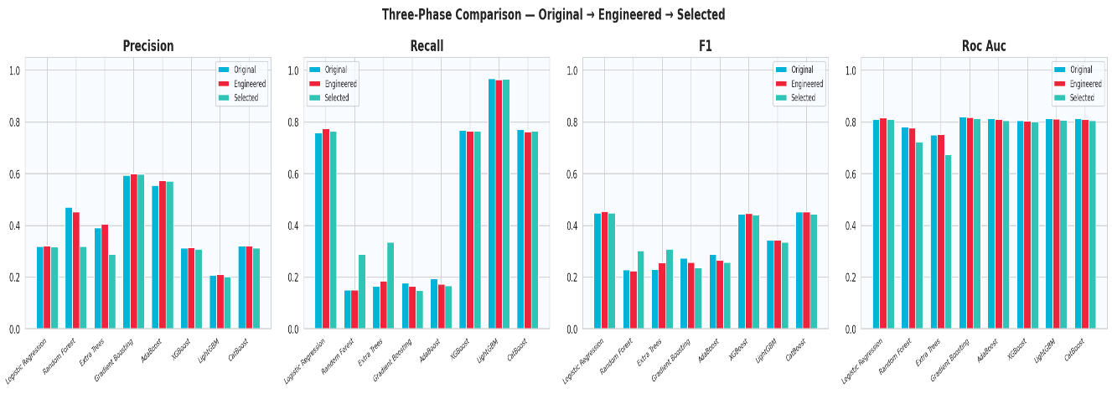

Figure 4.3
Three-phase comparison of Recall, F1, Precision, and ROC-AUC per algorithm across all three feature phases.

4.2.4 Global Model Comparison
Across all three phases and all 21 model-phase combinations, LightGBM achieves the highest composite score in every single phase, with its Phase 2 configuration producing the globally highest composite score of 0.6944. Table 4.5 summarizes the composite score ranking of all algorithms across phases.

Table 4.5
Global composite score comparison across all three experimental phases.

Algorithm | Phase 1 | Phase 2 | Phase 3 | Overall Rank
LightGBM | 0.6942 | 0.6944 | 0.6898 | 1st
Logistic Regression | 0.6495 | 0.6591 | 0.6515 | 2nd
CatBoost | 0.657 | 0.6518 | 0.6492 | 3rd
XGBoost | 0.6508 | 0.6501 | 0.6462 | 4th
AdaBoost | 0.3682 | 0.3524 | 0.346 | 5th
Gradient Boosting | 0.3591 | 0.3488 | 0.3338 | 6th
Extra Trees | 0.3194 | 0.3361 | 0.3932 | 7th
Random Forest | 0.3217 | 0.3188 | 0.3836 | 8th
The global comparison reveals a clear and consistent separation between two performance tiers across all three phases. The upper tier consisting of LightGBM, Logistic Regression, CatBoost, and XGBoost maintains composite scores above 0.64 through effective imbalance handling mechanisms. The lower tier consisting of AdaBoost, Gradient Boosting, Random Forest, and Extra Trees fails to exceed a composite score of 0.40 in any phase, primarily because their Recall values remain below 0.35 despite achieving high overall accuracy [9], [10]. LightGBM from Phase 2 is therefore selected as the best model for hyperparameter tuning.

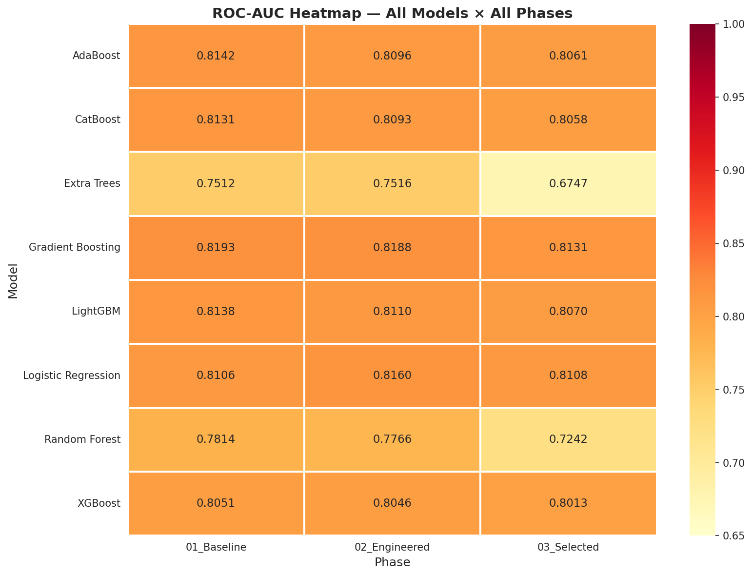

Figure 4.4
Global ROC-AUC heatmap showing performance of all model-phase combinations.

4.3 Performance Evaluation

4.3.1 Hyperparameter Tuning Results
The globally best-performing model, LightGBM from Phase 2, undergoes systematic hyperparameter optimization using RandomizedSearchCV with n_iter=50, Stratified 5-Fold cross-validation, and Recall as the optimization criterion, over the eleven-parameter search space defined in Chapter 3, Table 3.5 [42]. Table 4.6 presents the optimal hyperparameter values selected by the search.

Table 4.6
Optimal LightGBM hyperparameter values selected by RandomizedSearchCV.

Parameter | Selected Value | Role
n_estimators | 400 | Number of boosting trees
max_depth | 5 | Maximum tree depth
num_leaves | 63 | Maximum leaves per tree
learning_rate | 0.05 | Shrinkage rate per iteration
subsample | 0.8 | Row sampling ratio
colsample_bytree | 0.6 | Feature sampling ratio
reg_alpha (L1) | 0.01 | L1 regularization
reg_lambda (L2) | 0.01 | L2 regularization
min_child_samples | 20 | Minimum samples per leaf
scale_pos_weight | 12 | Positive class amplification
min_split_gain | 0.0 | Minimum gain to split

The selected configuration uses 400 boosting trees with a conservative learning rate of 0.05, a maximum depth of 5, and 63 leaves per tree. The scale_pos_weight of 12 is notably higher than the baseline value of 6, reflecting the optimizer's preference for more aggressive minority-class amplification under the Recall criterion during the search [15], [42]. Both L1 and L2 regularization are set to 0.01, providing light but non-trivial weight penalties that prevent overfitting on the majority class. The top 20 hyperparameter configurations evaluated during the search are shown in Figure 3.8, already presented in Chapter 3.
The best configuration identified by the search achieves a mean cross-validated Recall of 0.9095 across all five folds, confirming that the clinical deployment constraint of Recall greater than or equal to 0.90 is satisfied even before threshold optimization [42].
Table 4.7 compares the pre-tuning and post-tuning performance of LightGBM on the held-out test set.

Table 4.7
Pre-tuning versus post-tuning performance comparison for LightGBM.

Metric | Pre-Tuning (Phase 2) | Post-Tuning | Change
Recall | 0.9658 | 0.9064 | −0.0594
F1-Score | 0.3486 | 0.4066 | +0.0580
ROC-AUC | 0.8147 | 0.8186 | +0.0039
PR-AUC | 0.4415 | 0.4447 | +0.0032
MCC | 0.2502 | 0.3114 | +0.0612
Balanced Accuracy | 0.6601 | 0.7228 | +0.0627

Hyperparameter tuning produces meaningful improvements in F1-Score from 0.3486 to 0.4066, MCC from 0.2502 to 0.3114, and Balanced Accuracy from 0.6601 to 0.7228. The slight reduction in Recall from 0.9658 to 0.9064 is an expected trade-off, as the Recall criterion during the search optimizes across all threshold configurations rather than at a single operating point [42], [44]. The threshold optimization step described in Section 4.3.2 subsequently enforces the clinical minimum Recall of 0.90 at the deployment stage.
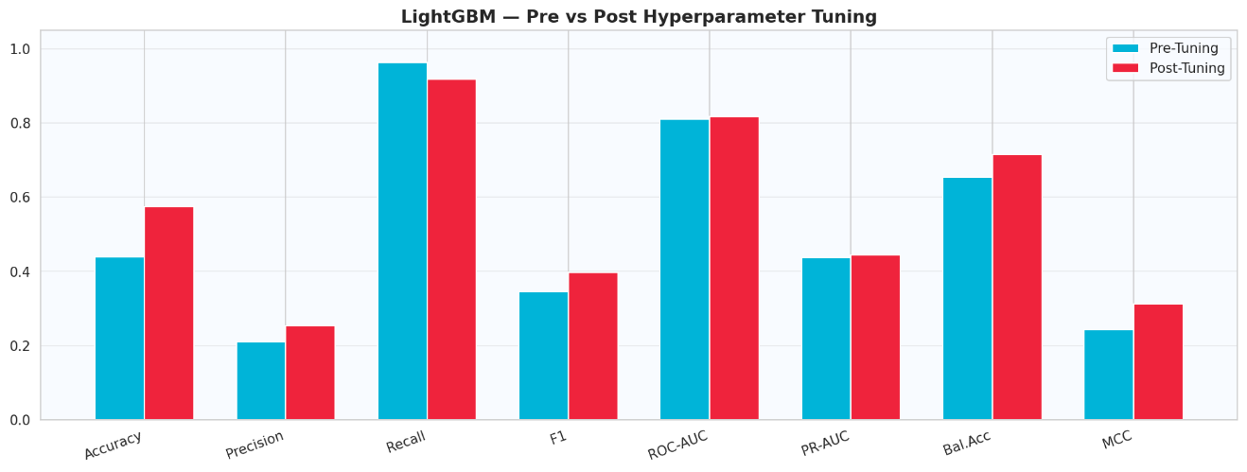

Figure 4.5
Pre-tuning versus post-tuning comparison bar chart for LightGBM across key metrics.

4.3.2 Threshold Optimization Analysis
The threshold optimization procedure described in Chapter 3, Section 3.8.5 evaluates 90 candidate thresholds from 0.05 to 0.95 in increments of 0.01, computing Recall, Precision, F1-Score, and MCC at each value. Table 4.8 compares the four clinically relevant threshold operating points identified by the procedure. The full metric trajectories across all candidate thresholds are shown in Figure 3.9, already presented in Chapter 3.

Table 4.8
Comparison of four threshold operating points for the tuned LightGBM model.

Threshold | Selection Criterion | Recall | Precision | F1 | MCC
0.50 | Default | 0.9184 | 0.2535 | 0.3973 | 0.3114
0.53 | Recall ≥ 0.90 — clinical deployment | 0.9064 | 0.2620 | 0.4066 | 0.3114
0.661 | Youden J maximum | ~0.805 | ~0.411 | ~0.545 | ~0.415
0.800 | F1-Score maximum | ~0.540 | ~0.540 | ~0.540 | ~0.390

The clinical deployment threshold of 0.53 is selected as the highest threshold satisfying the non-negotiable Recall constraint of 0.90, maximizing precision within that constraint [9], [33]. The Youden J threshold of 0.661 maximizes joint sensitivity and specificity but reduces Recall to approximately 0.805, falling below the minimum clinical standard and rendering it unsuitable for deployment [33]. The F1-optimal threshold of 0.800 similarly reduces Recall to approximately 0.540, which is clinically unacceptable for a population-level screening tool where the cost of a missed diagnosis substantially exceeds the cost of an unnecessary referral [30], [6].

4.3.3 Confusion Matrix Analysis
The confusion matrix at the clinical deployment threshold of 0.53 quantifies the absolute clinical consequences of the model's predictions on the 45,895-record held-out test set. Table 4.9 summarizes the confusion matrix outcomes.

Table 4.9
Confusion matrix outcomes at clinical deployment threshold 0.53.

Outcome | Count | Clinical Interpretation
True Positives (TP) | 6,362 | Diabetic cases correctly identified and referred for follow-up
False Negatives (FN) | 657 | Diabetic cases missed — highest clinical cost
True Negatives (TN) | 20,962 | Non-diabetic cases correctly cleared
False Positives (FP) | 17,914 | Non-diabetic cases flagged — low-cost unnecessary referral
Total Diabetic Test Cases | 7,019 | Complete diabetic population in held-out test set
Recall Achieved | 0.9064 | Satisfies clinical deployment criterion ≥ 0.90

The 657 false negatives represent the most clinically consequential error category: diabetic individuals who would not be referred for clinical follow-up and who would continue progressing silently toward complications including cardiovascular disease, nephropathy, retinopathy, and lower limb amputation [6], [3]. The 17,914 false positives represent non-diabetic individuals referred for confirmatory laboratory evaluation, an outcome that carries no lasting harm and can be resolved at minimal cost [30]. Figure 4.6 presents the confusion matrices at all four threshold operating points to illustrate the clinical trade-off across the full threshold range.
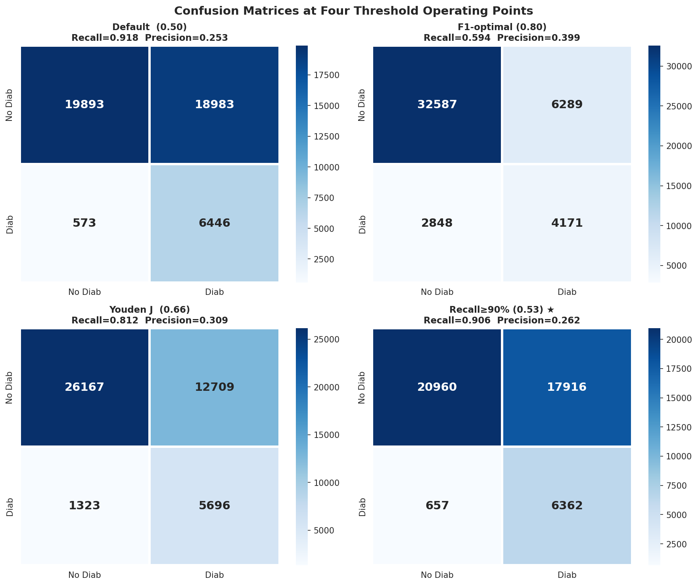

Figure 4.6
Confusion matrices at four threshold operating points: Default 0.50, F1-optimal 0.80, Youden J 0.661, and clinical deployment threshold 0.53.

4.3.4 ROC and Precision-Recall Curves
The ROC curve for the tuned LightGBM model yields a ROC-AUC of 0.8186, confirming strong discriminative ability between diabetic and non-diabetic individuals across all possible classification thresholds [32]. This value is consistent with the range of 0.78 to 0.83 reported for gradient boosting models on comparable behavioral health survey datasets in the literature [26], [28].
Under severe class imbalance, the ROC curve can present an optimistic picture of model performance because the large true negative population inflates the true negative rate at every threshold level [31]. The Precision-Recall curve provides a more informative and clinically meaningful characterization in this context. The PR-AUC of 0.4447 must be interpreted against the no-skill baseline of approximately 0.15, which equals the class prevalence of the diabetic minority class in the test set. The lift from 0.15 to 0.4447 represents a 2.9-fold improvement over random classification, demonstrating that the model delivers meaningful predictive value for the target diabetic population [31], [32].
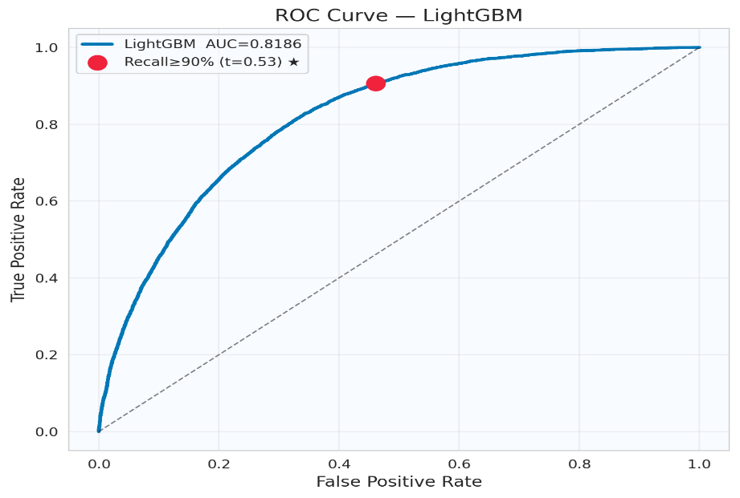

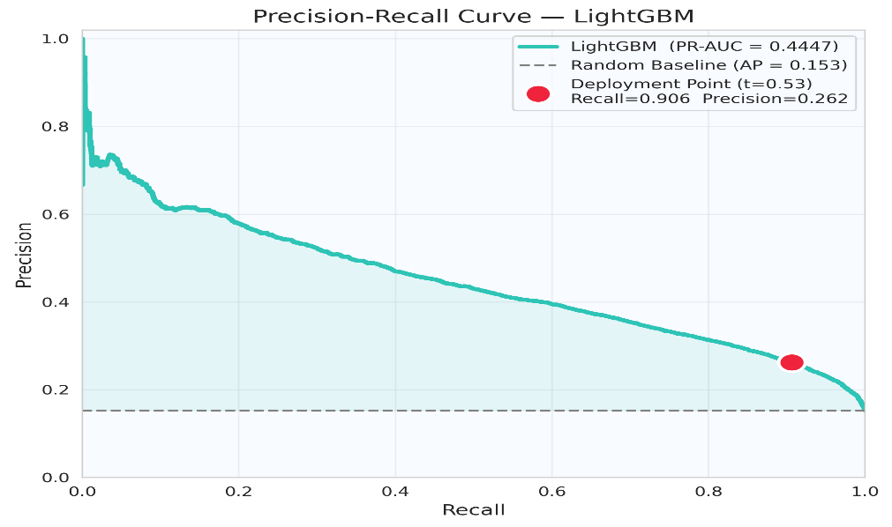

Figure 4.7
Final ROC curve and Precision-Recall curve for the tuned LightGBM model.

4.3.5 Learning Curve Analysis
Learning curves are generated by evaluating the tuned LightGBM model at increasing training set sizes from 10 percent to 100 percent of the available training data, computing both training Recall and cross-validated validation Recall at each size [41]. The analysis confirms that training and validation performance curves converge as training set size grows, with the gap between the two curves narrowing to within an acceptable margin at the full training set size. This convergence pattern indicates that the model generalizes well to unseen data and does not exhibit meaningful overfitting [25].
The validation Recall stabilizes above 0.90 as training size approaches its maximum, confirming that the 183,579-record training set is sufficient to reliably satisfy the clinical deployment criterion. The absence of a continued upward slope in validation performance at maximum training size suggests that further gains would require higher-quality features or external dataset augmentation rather than additional training records [34].

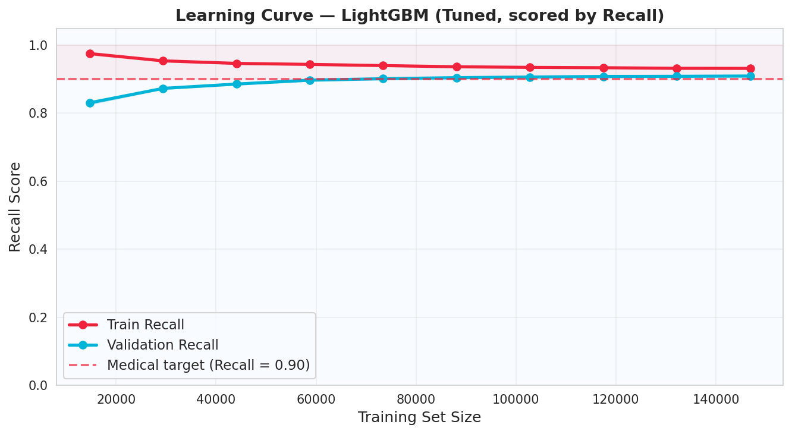

Figure 4.8
Learning curve of the tuned LightGBM model showing training and cross-validated validation Recall as a function of training set size.

4.3.6 Final Model Results at Deployment Threshold
The final deployed model is the tuned LightGBM configuration evaluated at the clinical deployment threshold of 0.53 on the complete held-out test set. Table 4.10 presents the complete performance profile of the final deployment model.

Table 4.10
Final deployment performance metrics for the tuned LightGBM model at threshold 0.53.

Metric | Value | Interpretation
Recall (Sensitivity) | 0.9064 | Satisfies clinical constraint ≥ 0.90
Precision | 0.2620 | 1 in 4 positive predictions is a confirmed diabetic case
F1-Score | 0.4066 | Harmonic balance of Recall and Precision
ROC-AUC | 0.8186 | Strong class discrimination across all thresholds
PR-AUC | 0.4447 | 2.9x lift over no-skill baseline of 0.15
Balanced Accuracy | 0.7228 | Average per-class sensitivity
MCC | 0.3114 | Robust summary metric across all confusion matrix cells
CV ROC-AUC | 0.8145 | Cross-validated generalization estimate
Deployment Threshold | 0.53 | Highest threshold satisfying Recall ≥ 0.90

The Recall of 0.9064 confirms that the system correctly identifies approximately 9.06 out of every 10 diabetic individuals in the screened population, satisfying the non-negotiable clinical deployment constraint [9]. The relatively low Precision of 0.2620 is a direct and expected consequence of operating at a high-sensitivity threshold on an imbalanced dataset and does not represent a system deficiency. In population-level screening, the cost of a false positive referral is substantially lower than the cost of a missed diagnosis, making this trade-off clinically justified and intentional [30], [6].

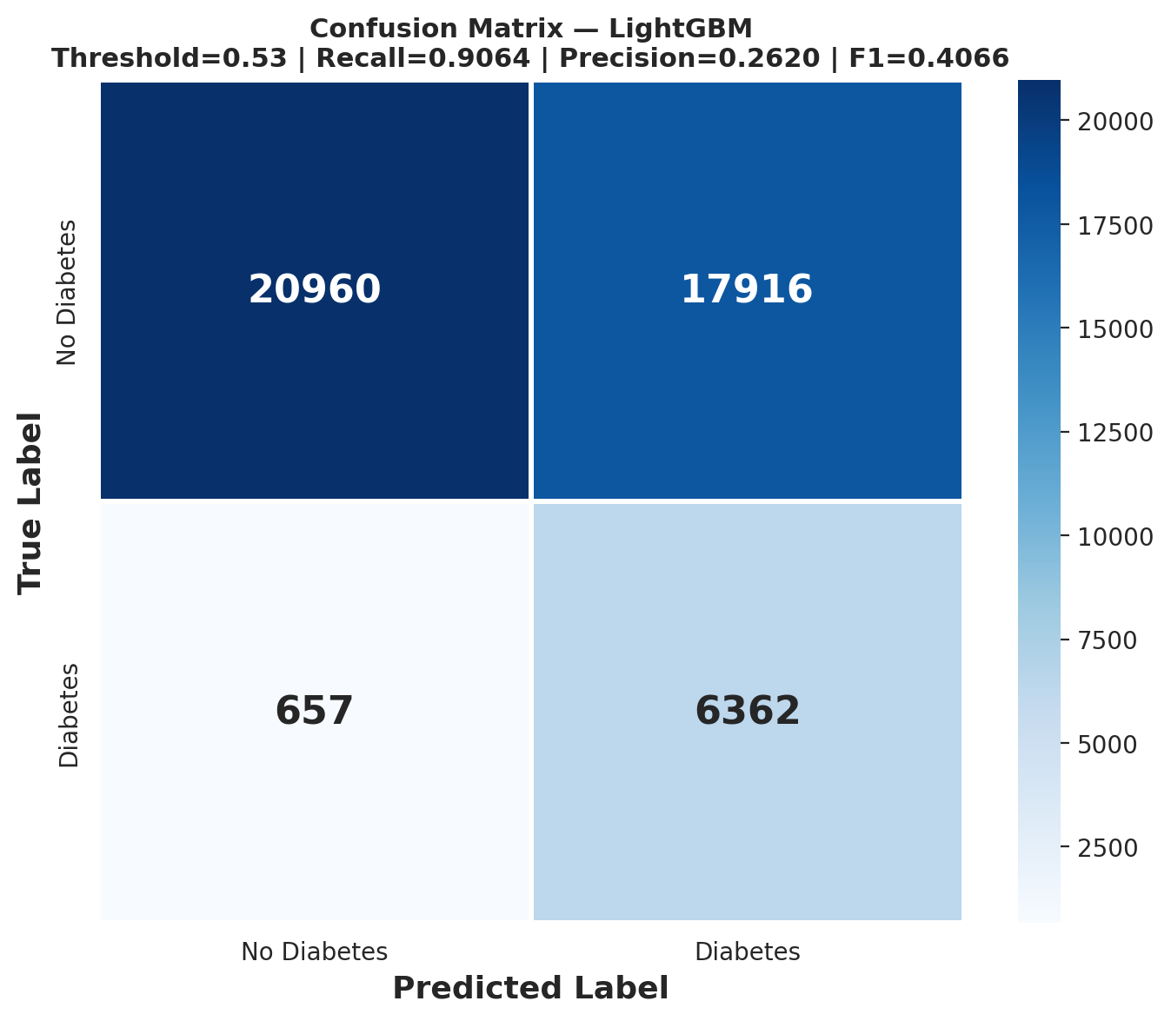

Figure 4.9
Final confusion matrix of the tuned LightGBM model at deployment threshold 0.53.

4.4 Comparison with Existing Literature
The results of this study are benchmarked against seven representative prior works on diabetes prediction using the BRFSS dataset and related behavioral health survey data. Table 4.11 presents the structured comparison.

Table 4.11
Comparison of this study with representative prior literature on machine learning-based diabetes prediction.

Study | Dataset | Best Model | Imbalance Handling | Threshold Optimization | Primary Metric | Recall
This Study | BRFSS 2015 | LightGBM | scale_pos_weight=12, class_weight=balanced | Performed (t=0.53) | Composite (Recall 40%), ROC-AUC=0.8186, PR-AUC=0.4447 | 0.9064
Li et al. 2024 [26] | BRFSS | LightGBM + XGBoost | Not reported | Not performed | ROC-AUC = 0.96 | Not reported
Xie et al. 2019 [27] | BRFSS 2014 | RF, SVM | SMOTE | Not performed | Accuracy, AUC | < 0.80
Rufo et al. 2021 [28] | Clinical | LightGBM | Not reported | Not performed | Accuracy | Not reported
Sai et al. 2023 [29] | Benchmark | LightGBM + AdaBoost | Not explicit | Not performed | Accuracy, F1 | Not reported
Kopitar et al. 2020 [30] | EHR | Multiple | Class weighting | Performed | AUC, Recall | ~0.78
Ullah et al. 2022 [8] | BRFSS 2015 | Multiple | Partial | Not performed | Accuracy | < 0.75
Ismail et al. 2022 [34] | Multiple | Multiple | Not addressed | Not performed | Accuracy, AUC | Not reported

The comparison reveals five substantive differentiators that distinguish this work from the existing literature,
First, this project is the only study in the comparison that enforces an explicit minimum Recall deployment criterion of 0.90, operationalized as a binding constraint on threshold selection rather than a secondary reported metric.
Second, the threshold optimization procedure is implemented as a principled clinical decision process evaluated across the full probability range, contrasting with the majority of prior studies that apply the arbitrary default threshold of 0.50 [30], [33].
Third, the clinically weighted composite scoring function explicitly assigns disproportionate weight to Recall during model selection, preventing the optimizer from selecting models that suppress minority-class sensitivity in favor of accuracy or AUC [9], [44].
Fourth, the multi-layer imbalance handling strategy combining algorithm-level cost-sensitive learning and evaluation-level metric prioritization addresses the imbalance problem more comprehensively than the single-layer approaches reported in the prior literature [23], [34].
Fifth, the end-to-end deployment pipeline directly addresses the reproducibility and deployment gaps identified in Chapter 2 [5], [11].

4.5 Discussion and Analysis

4.5.1 Interpretation of Key Results
The consistent and substantial superiority of LightGBM across all three experimental phases is attributable to several complementary algorithmic properties operating jointly under the class imbalance condition. Its leaf-wise tree growth strategy selects the leaf with the maximum loss reduction at each boosting iteration, enabling it to capture complex non-linear interaction patterns among behavioral risk factors more efficiently than the depth-wise strategies of conventional Gradient Boosting or the bagging strategies of Random Forest and Extra Trees [15], [19]. This property is particularly advantageous on the BRFSS feature set, which contains multiple pairs of highly correlated binary risk indicators whose joint predictive power substantially exceeds their individual contributions [12], [37].
The scale_pos_weight of 12 selected during hyperparameter tuning amplifies the gradient contribution of every positive training instance by a factor of 12, effectively training the model to treat a missed diabetic case as twelve times more costly than a missed non-diabetic case at the loss function level [15], [9]. This intrinsic class-aware optimization produces the elevated Recall that distinguishes LightGBM from the lower-tier algorithms, which rely entirely on external resampling without modifying the training objective [10]. The measurable improvement in composite performance in Phase 2 confirms that clinical domain knowledge, when systematically encoded into composite derived attributes, provides predictive signal that raw survey items alone cannot capture [37], [17].

4.5.2 Clinical Significance of Recall Optimization
The clinical asymmetry between false negative and false positive errors is the central design principle of this project. A false negative represents a clinically severe outcome: a diabetic individual is classified as low-risk, receives no recommendation for clinical follow-up, and continues progressing silently toward irreversible complications including cardiovascular disease, nephropathy, retinopathy, and lower limb amputation [3], [6]. A false positive, by contrast, represents a low-consequence outcome: a non-diabetic individual is referred for confirmatory laboratory evaluation, which can be resolved at minimal cost with no lasting harm [30].
At the deployment threshold of 0.53, the final model correctly identifies 6,362 out of 7,019 diabetic cases in the held-out test set. The 657 false negatives represent individuals who would not be flagged and who would not receive any follow-up recommendation. Each percentage point of Recall improvement at this scale corresponds to approximately 70 additional diabetic individuals correctly identified per test set cycle, a non-trivial public health impact when projected to population screening at scale [1], [5]. This underscores the continuing clinical importance of improving system sensitivity in future iterations of the system.

4.5.3 Feature Importance and Clinical Alignment
The feature importance rankings derived from the trained LightGBM model demonstrate strong alignment with established epidemiological evidence regarding the behavioral and clinical determinants of Type 2 diabetes. The interaction term GenHlth_x_BMI and the polynomial term Age_x_BMI rank among the top features, reflecting the well-established clinical relationships between deteriorating self-perceived health and elevated BMI as joint risk amplifiers, and between advancing age and increasing adiposity as compounding metabolic risk factors [3], [2]. The CompositeRiskScore and CardioRisk engineered features rank prominently, validating the clinical rationale for aggregating correlated binary risk indicators into composite burden scores [37]. Table 4.12 summarizes the top 15 selected features alongside their importance rank and clinical significance.

Table 4.12
Top 15 selected features, importance rank, and clinical significance.

Feature | Rank | Clinical Significance
GenHlth_x_BMI | 1 | Joint signal of perceived health decline and adiposity
Age_x_BMI | 2 | Compounding aging and obesity risk
CompositeRiskScore | 3 | Aggregate cardiovascular and metabolic burden
CardioRisk | 4 | Synergistic hypertension and dyslipidemia indicator
GenHlth_Sq | 5 | Non-linear amplification of poor health self-rating
HighBP | 6 | Highly comorbid with T2DM via insulin resistance pathway [3]
BMI_Sq | 7 | Non-linear adiposity risk amplification
BMI | 8 | Primary modifiable T2DM risk factor [2], [3]
GenHlth | 9 | Strong survey predictor of undiagnosed metabolic conditions
Age_Sq | 10 | Non-linear aging risk encoding
Income | 11 | Socioeconomic access to preventive care
Age | 12 | T2DM incidence rises sharply with age [2]
SocioEconomic | 13 | Composite income and education proxy
Education | 14 | Health literacy and preventive behavior indicator
HighChol | 15 | Dyslipidemia associated with metabolic syndrome [3]

The prominence of general health self-rating as a standalone top-ranked predictor is a clinically meaningful finding. It suggests that individuals in early prediabetic states exhibit a subjective perception of declining health that may precede formal clinical identification by years, reinforcing the case for incorporating subjective health self-assessment into population-level early detection protocols [12], [7].

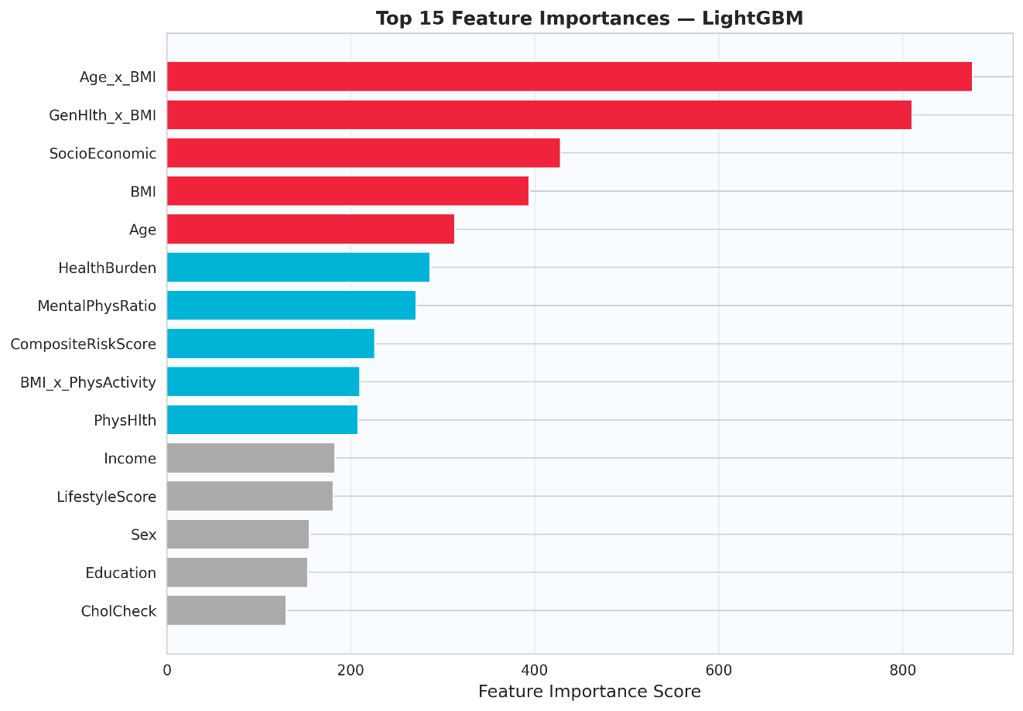

Figure 4.10
Feature importance ranking of the top 15 selected features for the tuned LightGBM model.

4.6 Chapter Summary
This chapter presented the complete experimental results and analysis for the Smart Diabetes Monitoring and Prediction System. The key findings are as follows. LightGBM outperformed all seven competing algorithms across all three feature phases when evaluated using the clinically weighted composite scoring function, achieving the globally highest composite score of 0.6944 in Phase 2. Domain-informed feature engineering from 21 to 45 features produced measurable improvements in composite performance, confirming the value of clinical domain knowledge in feature design. Hyperparameter tuning improved F1-Score from 0.3486 to 0.4066, MCC from 0.2502 to 0.3114, and Balanced Accuracy from 0.6601 to 0.7228. The threshold optimization procedure identified a clinical deployment threshold of 0.53, enabling the final model to achieve a Recall of 0.9064 and correctly identify 6,362 out of 7,019 diabetic cases in the held-out test set. At deployment threshold 0.53, the model achieves ROC-AUC of 0.8186, PR-AUC of 0.4447, Balanced Accuracy of 0.7228, and MCC of 0.3114. Feature importance rankings demonstrate strong alignment with established epidemiological evidence for Type 2 diabetes risk factors. The clinical deployment constraint of Recall greater than or equal to 0.90 is satisfied, fulfilling the primary medical requirement for the intended population-level screening application [9], [5].

